MVLL Board Meeting
December 8, 2022

Attendance
- Jeremy Donelson
- Jake Millman
- Lisa Treasure
- Christina Brown
- Walter Brown
- John Malloy
- John Visconti
- LJ Warren

Previous Meeting Minutes
October 2022 Minutes- All in favor to approve.

Elections
Jeremy nominates John Malloy for Concessions Manager; Lisa seconds; all in favor.

Financial Update
Matt presented financial review of 2022 and potential budgets for 2023 season.
2023 Budget
    - The feedback was great for clinics. The board would like to include baseball into clinics at DYS for 2023. Propose to increase clinic budget to $1200.
    - There was a large investment in equipment in 2022. This would not need to happen in 2023. Proposed reduction equipment budget to $2100
    - The league would like to have the league represented within the community more. The marketing budget would be used for flyers, stickers, banners etc. The community outreach budget would be used for Town days, Dunk tank, Phoenicia Elementary Holiday Boutique, Woodstock Elementary KidStock, etc. Propose combining marketing and community outreach budget to $1500.
    - With John Malloy being elected for Concession Manager the concession budget may need to be revisited. Proposed Budget for concessions to be $1000 with possible increase for upgrade to concession facility.
    - The league purchased dirt in 2022 that should be enough for 2023 season. May need to consider cost of dirt at Grant Avery. The agreement with Town of Olive is the league will pay for the difference if dirt preferred by the league is used. Proposed field related expenses budget to be $2000.
    - In 2022 the league experienced a few issues while trying to buy uniforms which resulted in higher costs. Ideas to avoid this issue for 2023 would be purchasing earlier, looking for a local vendor with competitive pricing, buying pants online vs local. Proposal of the league not providing pants or possibly kid pitch divisions would receive belt loop pants and coach pitch and tball would receive the stretch.
    - Registration amount for players will remain the same as 2022.

Final budget for 2023 season will be put together from these proposals and reviewed at following meeting.

Regular Meeting Schedule
Going forward the MVLL board meetings will take place on the third Thursday of the month at 630pm. For winter the meeting place will be at the Boiceville Inn.

Field Cleanup
Glenbrook snack shack is cleaned out. Jeremy would like to sort the equipment shed into baseball, softball and t-ball this weekend. Banners along the fence would be taken down at this time as well. Walter currently has majority of the softball equipment in his garage ready to put in Glenbrook shed once organized. Walter is taking down the banners 12/9 at Phoenicia Elementary. Rick Volz has been cleaned out.

2023 Season
      - Registration opens January 1. Geordarna Constant potential Information Director but would need to be present to be nominated and voted onto board.
      - Winter Clinics can start being planned. Walter would like to use Phoenicia Elementary for softball clinics. Phoenicia Elementary is covered under the insurance policy so building usage form can be submitted to the school district. The district reminded the league that anyone coming to clinics or onto the field with players they need to have a background check. Highly encouraged to include background check for parents on the registration. This includes concession volunteers.
        - Promotion/marketing- Flyers to be sent out through schools and other programs. A marketing tool to be used is Facebook ads. Proposed to form a marketing and fundraising committee to brainstorm more and put these together.

Town of Olive Recreation Meeting
Jeremy attended the November Olive Rec meeting. Jeremy would communicate with Olive for MVLL. The recommendation will be to play at Grant Avery as it is centrally located. The town offered to provide dirt, lime, paint and a set of balls with the use of the field. If the league wants to use preferred dirt the league would be responsible for the difference in cost. There was a request from the town to use the lights appropriately. Davis park would be used by modified baseball this year but it can still accommodate 4 T-Ball games. Next meeting Jeremy attends the focus will be on the field schedule. The League will continue to use the other 3 fields. Softball would need to find an alternative located field to fulfill the needs of the entire district if not using GA as a primary field.

Indian Valley Dodgeball Tournament
On January 21, 2023 our neighboring district, Indian Valley, is hosting a dodgeball tournament to raise funds towards field renovations. This will be held at the Marbletown Municipal Building in Cottekill at 12pm. Jeremy proposes sending a team from MVLL all in favor.

Survey Update
Survey has been formed on hosting site Survey Monkey. It still needs some editing. The current plan is to send out the survey with new year registration emails.

Open Board Seats
Currently have three potential candidates to fill open board seats. Chris Constant, Coach Cordinator; Geordarna Constant, Info Director; Jane Simmons, Safety Officer. They will be voted in at the next meeting they are present for.
Remaining positions to be filled are Field Manager and Umpire Cordinator. Past Umpire cordinator Amanda Longo has offered to help transfer the position responsibilities.

Comments
Our District Manager, John Visconti, attended the meeting. He expressed numerous times his phone and email are always open.

Next Meeting
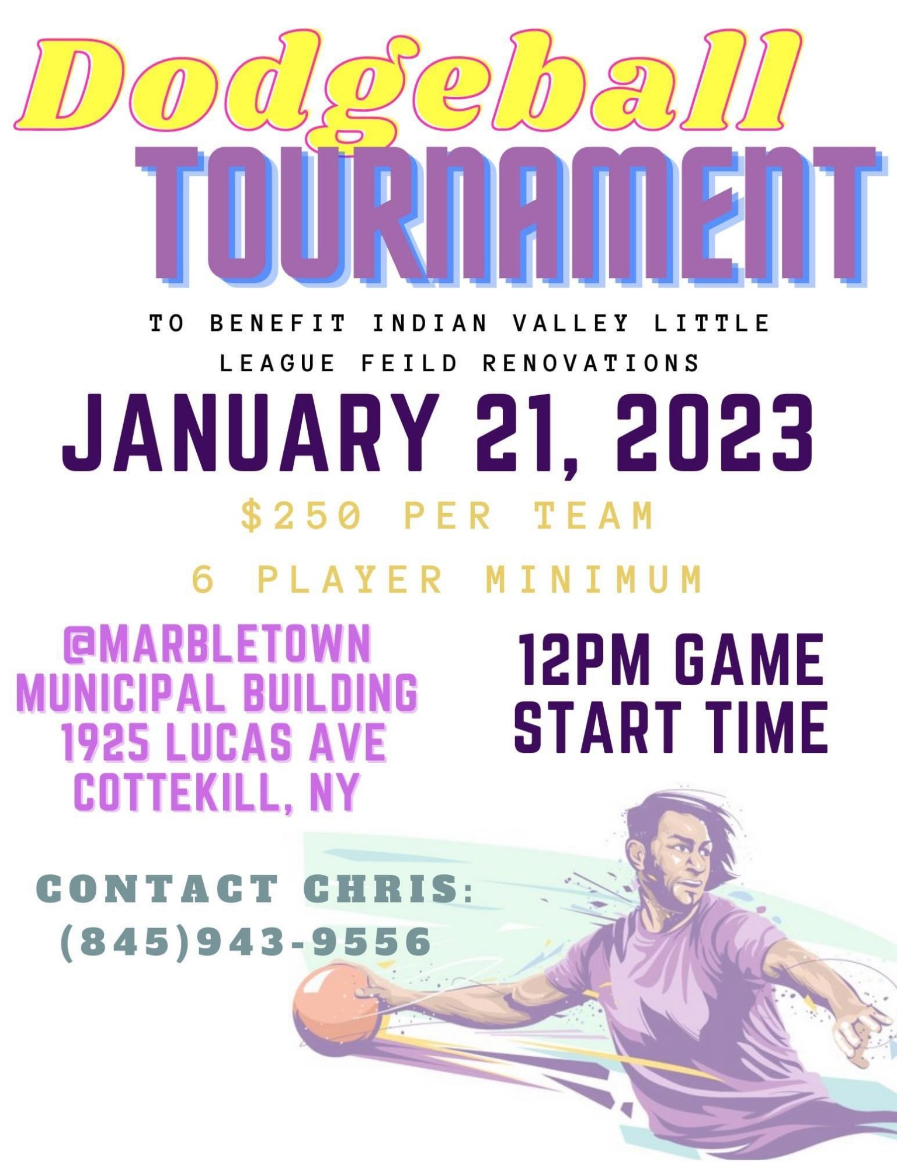
January 19, 2023 6:30pm at the Boiceville Inn, Boiceville, NY

